

Automation Test
Setup & Execution Instructions

TABLE OF CONTENTS

1. Prerequisites and Installations 3
1.1 JDK 3
1.2 Node js 3
2. Tortoise SVN 4
3. Setup 5
4. NetBeans IDE 5
5. Automation Scripts Execution 5
6. Reports 7
7. Npm-Modules 8
7.1 List of npm modules and their usage 9

1. Prerequisites and Installations

1.1 JDK
- Download jdk 8 from the URL - http://www.oracle.com/technetwork/java/javase/downloads/jdk8-downloads-2133151.html and install.
- Set path variable to include “Jdk install location\bin” and verify it by entering “Java –version” in command prompt. Make sure that the following message displayed.
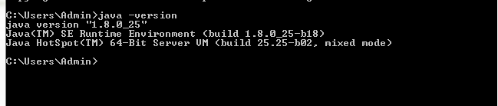
Fig 1.1 Installing JDK

1.2 Node js

- Install Node.js by double clicking on the “Install_NodeJS.bat” batch file which is located in the “install” folder. To check whether installation is successful or not, execute the command “node --version” in the command prompt as shown in below window.
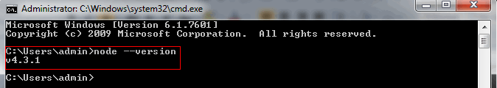
Fig 1.2 checking installed node version.

2. Tortoise SVN

- Download tortoise svn from http://tortoisesvn.net/downloads.html and install it.

- After installing, create a folder in any location in your machine .And right click on it, you will get a couple of svn options.
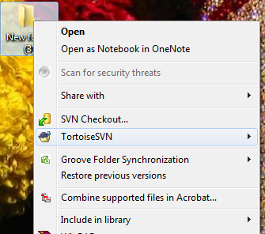
Fig 1.3 SVN options on right click
- Click on svn checkout, it will ask for project url path, from where you want to download.

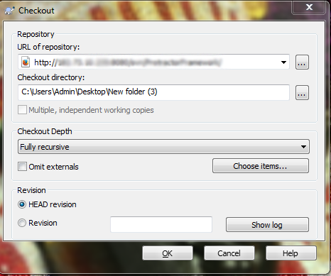
Fig 1.4 SVN Url prompt.
- After entering the proper svn url, click on ok it will ask for authentication credentials.
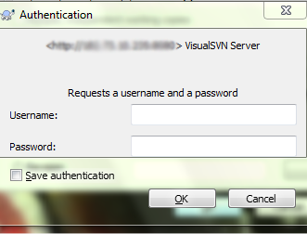
Fig 1.5 Authentication prompts.
- Enter valid credentials and click on “ok” it will start downloading your project files.
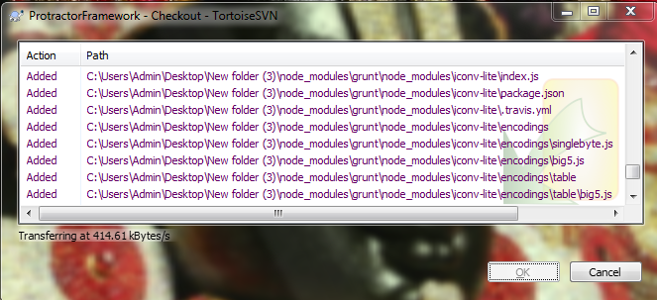
Fig 1.6 Downloading project files.

3. Setup
- Install nightwatch and other required node modules by double click on the “Setup.bat” file which is located in the ‘install’ folder.

4. NetBeans IDE

To configure netbeans IDE and to import existing project into netbeans IDE please refer “Working with NetBeans IDE” document under “Documents” folder in framework.

5. Automation Scripts Execution

To execute the scripts in local machine, Follow the below two steps
  - Navigate to ‘configurations’ folder and provide the required browser name in ‘local.json’ file as shown below
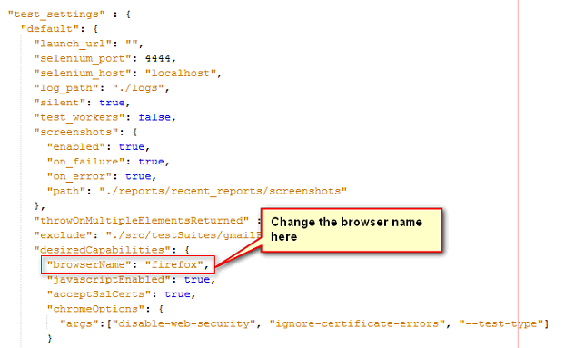
  - After providing the browser name, navigate to ‘run’ folder and double click on the “runTestsOnLocal.bat” batch file, it will invoke grunt file and starts executing the scripts from local machine.

- To execute the scripts in saucelabs, follow the below two steps
  - Navigate to ‘run_utilities’ folder and provide required browser names in ‘runParallel.bat’ batch file. Open batch file and follow the below mentioned naming convention while specifying the browser names.
For Chrome browser = chrome
For Firefox browser = firefox
For Internet explorer = iexplorer
E.g. Specify chrome, Firefox in ‘runParallel.bat’ for running the tests in chrome and Firefox

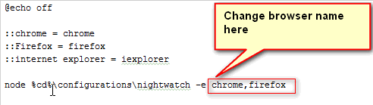
  - After providing the required browser names in ‘runParalle.bat’ file, navigate to ‘run’ folder double click on the “runTestsOnSaucelabs.bat” batch file , it will invoke grunt file and starts executing the scripts from saucelabs.

6. Reports
- Once done with the execution, the run will automatically invoke the “Report.bat” which will generate the reports. Line by line execution can be seen by clicking ‘View LogOutPut’ link.

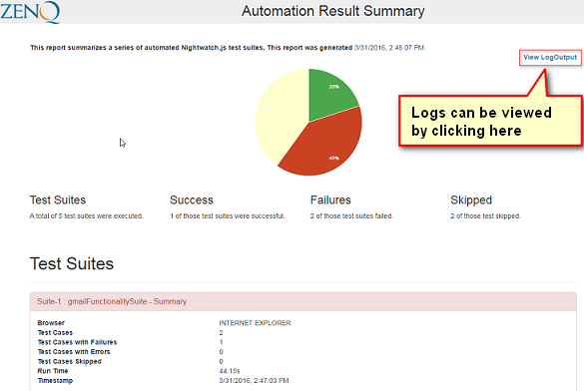

- In case of failure, screenshots can be viewed by clicking “View Screenshot” link
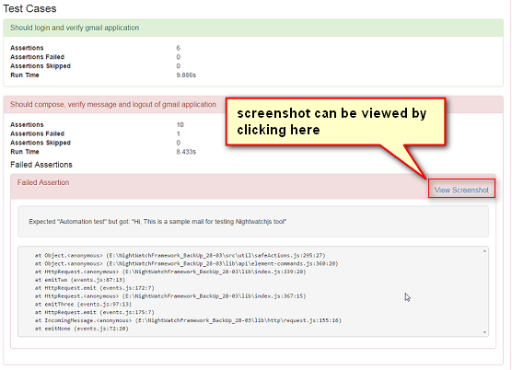
Fig 1.7 Nightwatch test report

7. Npm-Modules
Project dependent npm modules are installed through command line and manage dependencies for a project. The framework is provided with single batch file “setup.bat”, which will install all the dependency modules when double clicked on it.
To install modules separately (manually) use the following commands specified after each module description.
The general syntax to install a module is
- npm install –g moduleName (to install globally)
- npm install moduleName --save-dev (to install it locally in project)

7.1 List of npm modules and their usage

nightwatch:
To install nightwatch, we use the following command
- npm install nightwatch –save-dev
Grunt:
Grunt is a JavaScript task runner, helps to perform repetitive tests. This is built on top of node.js. It wraps up jobs into tasks that are compiled automatically.
To install grunt in nightwatch, we use the following command
- npm install grunt –save-dev
If the grunt doesn’t recognize after installing, do install grunt-cli globally using
- npm install grunt-cli -g
Log4Js:
Log4js is a very small but useful JavaScript library to log events in your scripts. Often it is not useful to use alert ('debug message'). To install log4js in our library, type
- npm install log4js –save-dev
Grunt cli:
grunt command line interface is used when the grunt doesn’t gets recognized in local. Grunt cli is installed globally.
To install grunt cli, type the following command.
- npm install grunt-cli -g
Init:
This package will create the package.JSON file. This JSON contains the information about the list of modules and their versions installed. To install type
- npm init
trayballoon:
This npm is used to provide balloon popup for currently running test case. The balloon popup will appear with current running test case when the test case started. To install this npm
- npm install --save trayballoon
async:
Async is a utility module which provides straight-forward, powerful functions for working with asynchronous JavaScript. To install
- npm install --save async

